**Project Problems**

**The Assignment is really cool. I loved working on it. But there are several problem which I faced.**

**Problems**

1. **Captcha automation problem**
2. **Loading of the next page through code. I’m getting connection time out error.**

**Solutions**

1. **There is a bug which I found in the maharastra govt website. Captcha which is shown in the page and if you load the captcha through the href link then both are different which is correct. But when you enter different captcha in the field it will give you the results.**

**How I tried reading the Captcha?**

**The process which I want to use is to load the captcha through another link and then read the captcha through OCR(Optical character recognition) and get the desired text.**

**I’m attaching the code for it.**

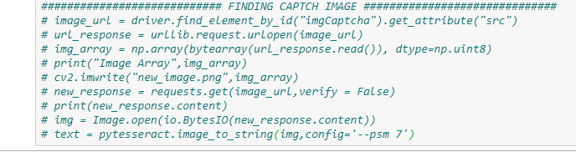

**The Second option which I choose is the user can enter the captcha on their own either on terminal or in the website itself.**

**To enter on the Website I just have to comment one line.**

1. **For the Next page loading i choose to get the element x-path and editing it by using for loop. I tried it but I’m getting the connection time Out error.**
2. **The code doesn’t contains the loop over the village postal code which is from 1to 9999 because every time user has to enter the captcha and it will hectic to enter the captcha this many time.**

**I tried to finish the whole work but there are few problems in which I need help. Hope to have a discussion over it.**